Computer Network-Lab Assignment 1

Archit Bagad

SY-AI&DS(A)

PRN-12311951

Roll no. 25

1.Nslookup

Performs DNS lookups to resolve domain names into IP addresses.

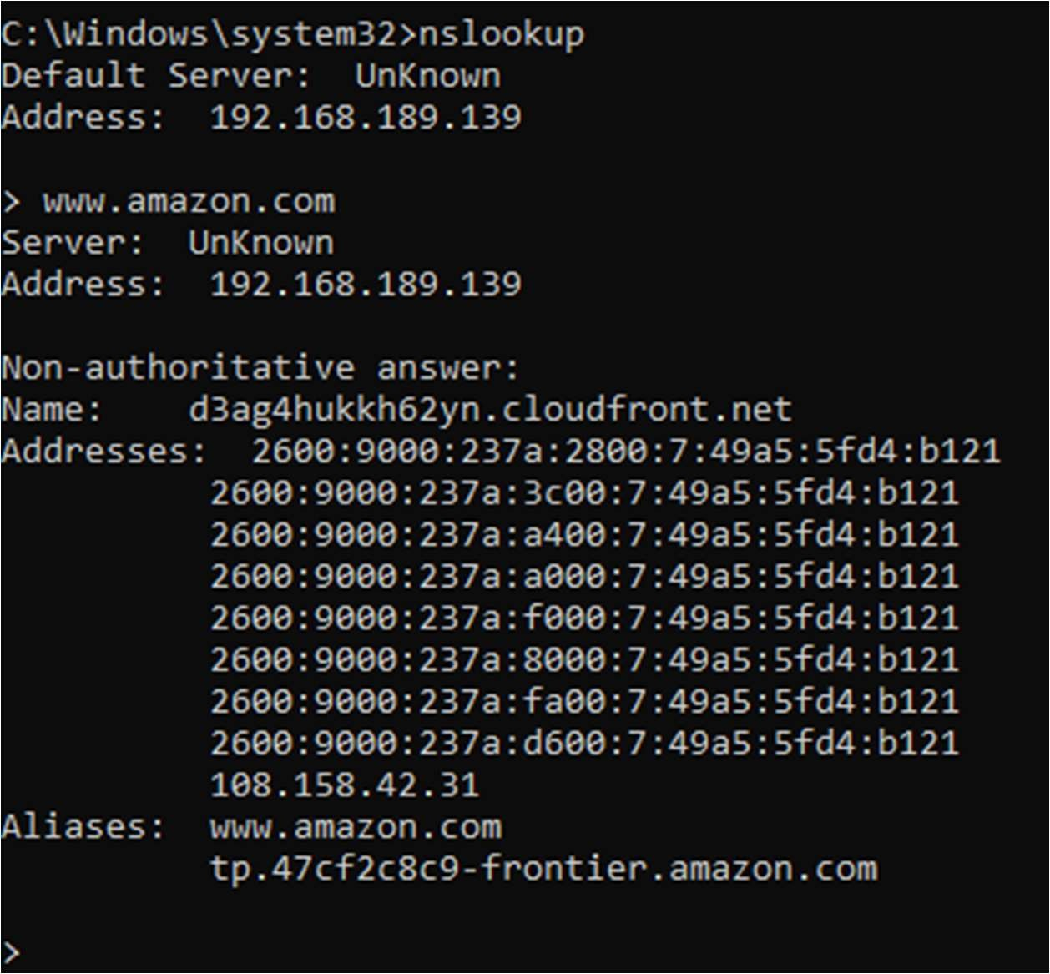

2.Ipconfig

Displays IP address, subnet mask, and default gateway for all network interfaces.

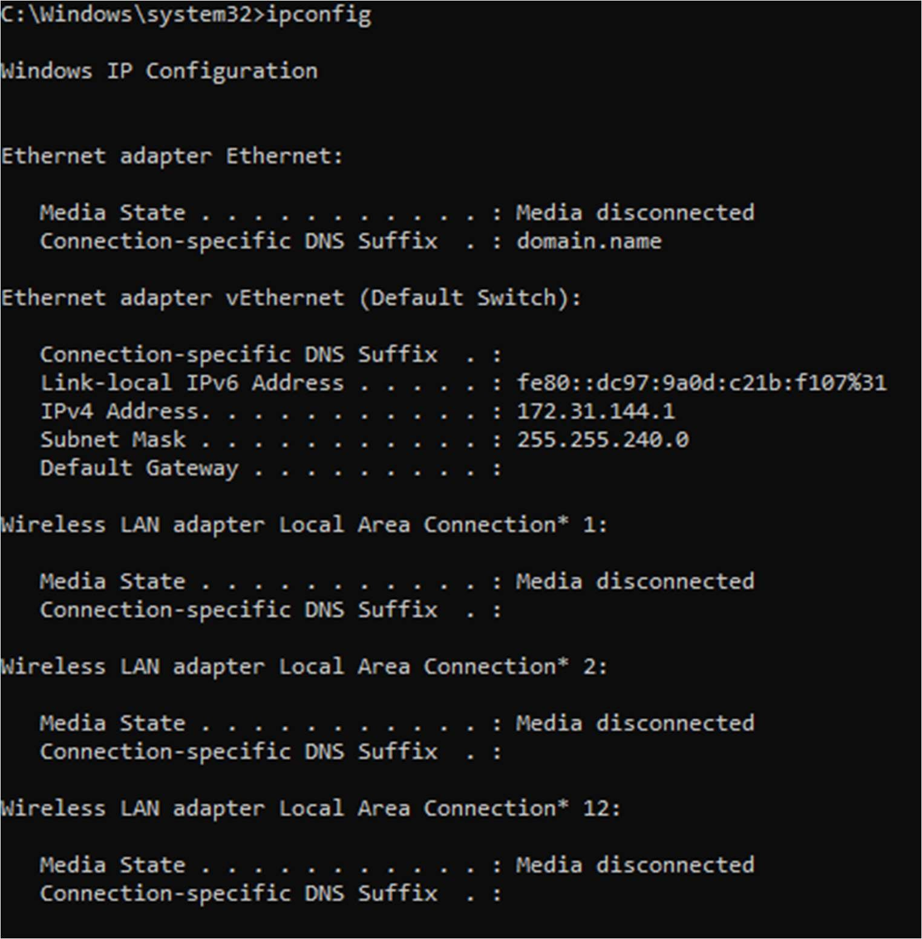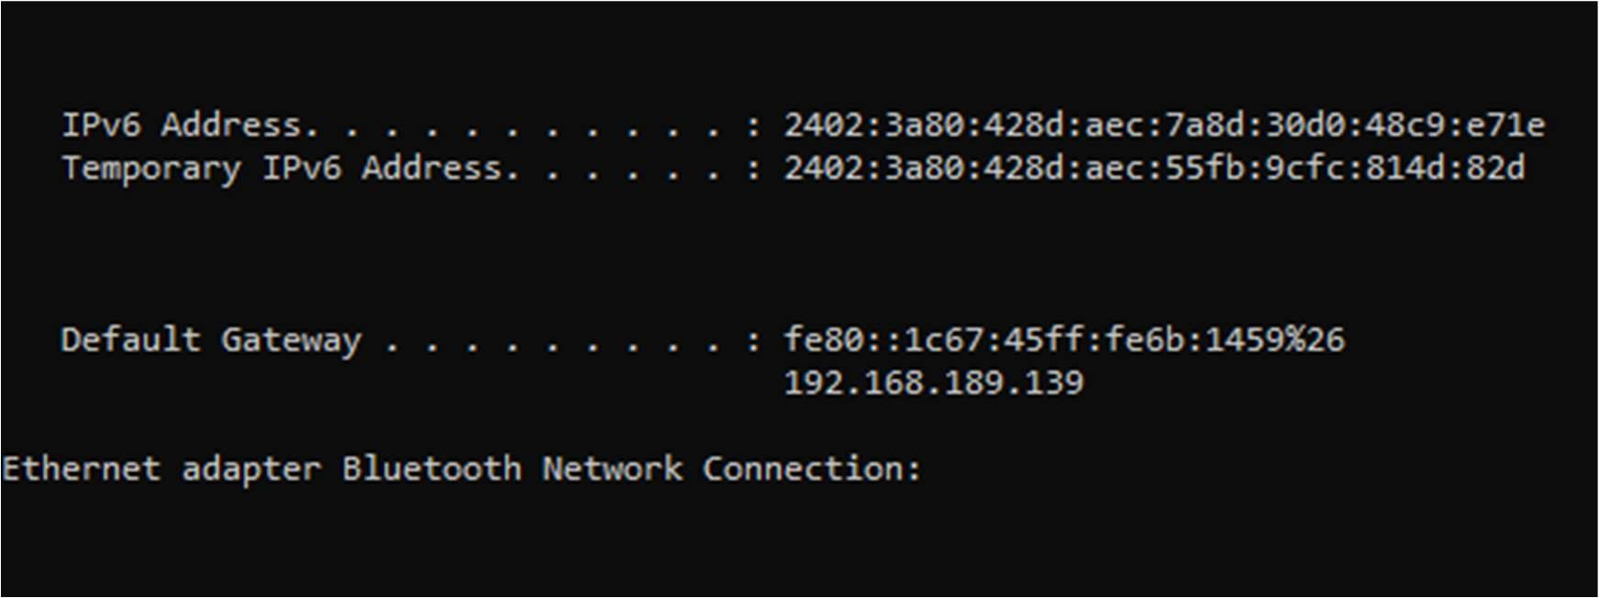

3.Hostname

Displays the computer's hostname.

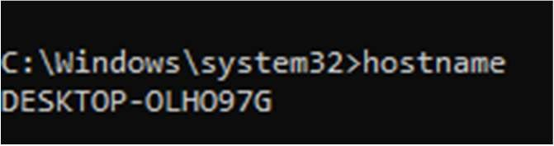

4.Ping

Tests the reachability of a host.

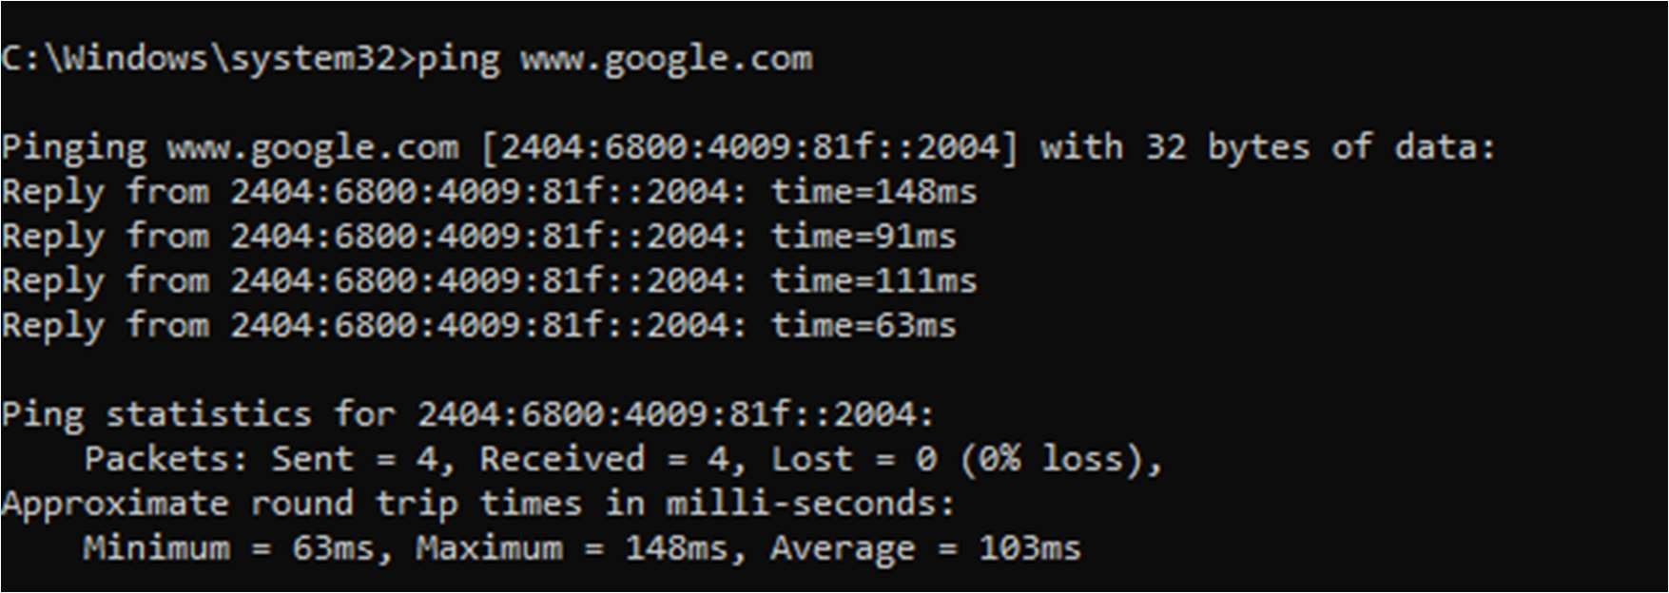

5.netsh

Configures network interfaces and performs other advanced tasks.

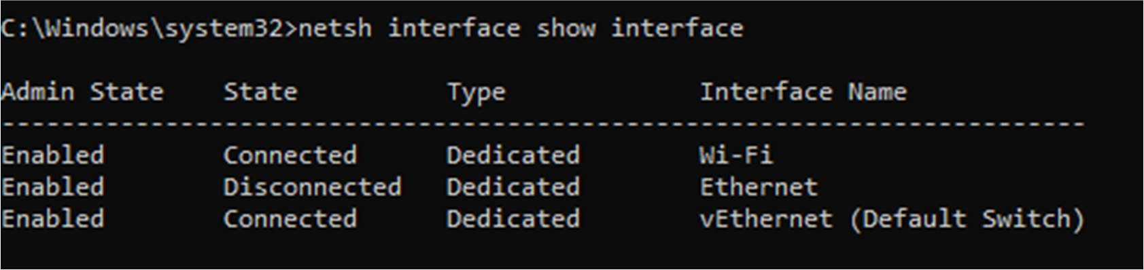

6.route print

Display the rou ng table, ac ve network connec ons, and interface list on a Windows system.

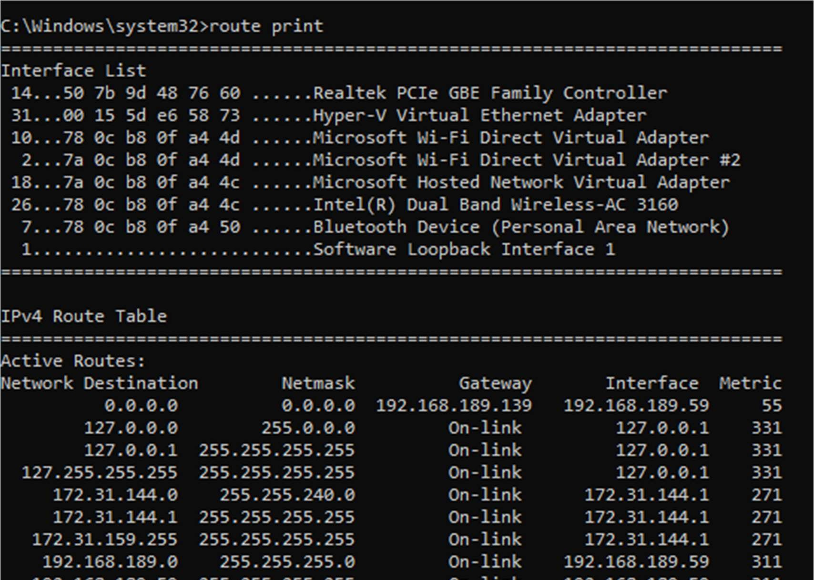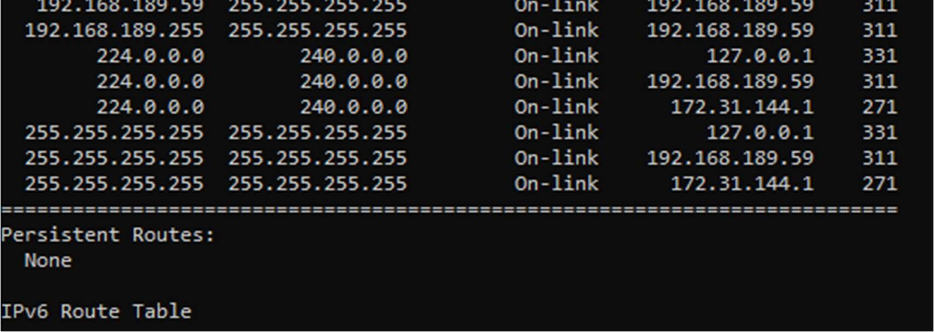

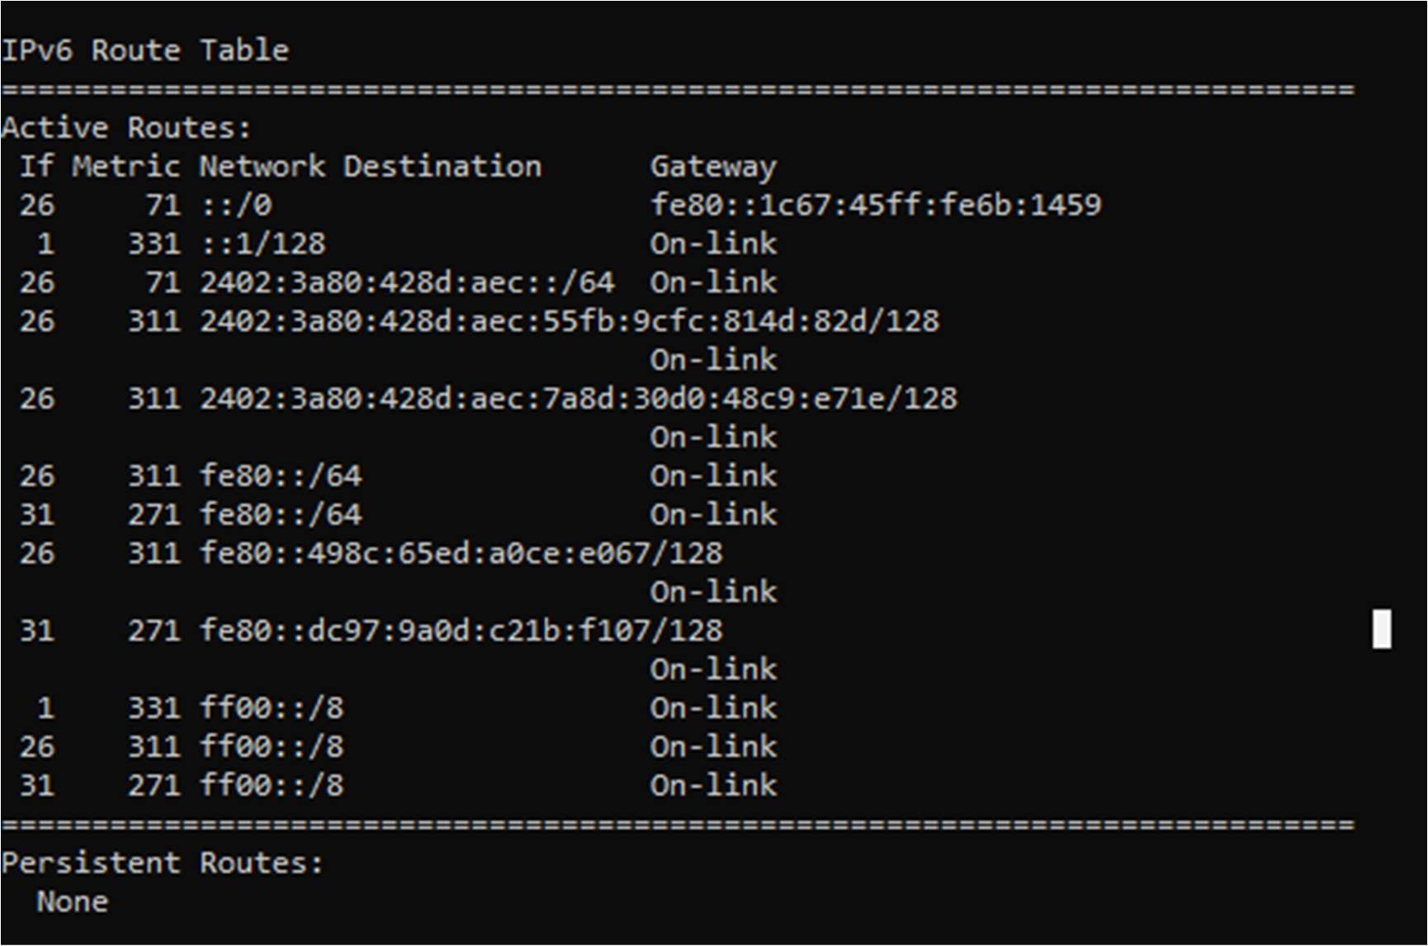

7.systeminfo

Displays detailed informa on about the computer’s hardware, opera ng system, and configura on.

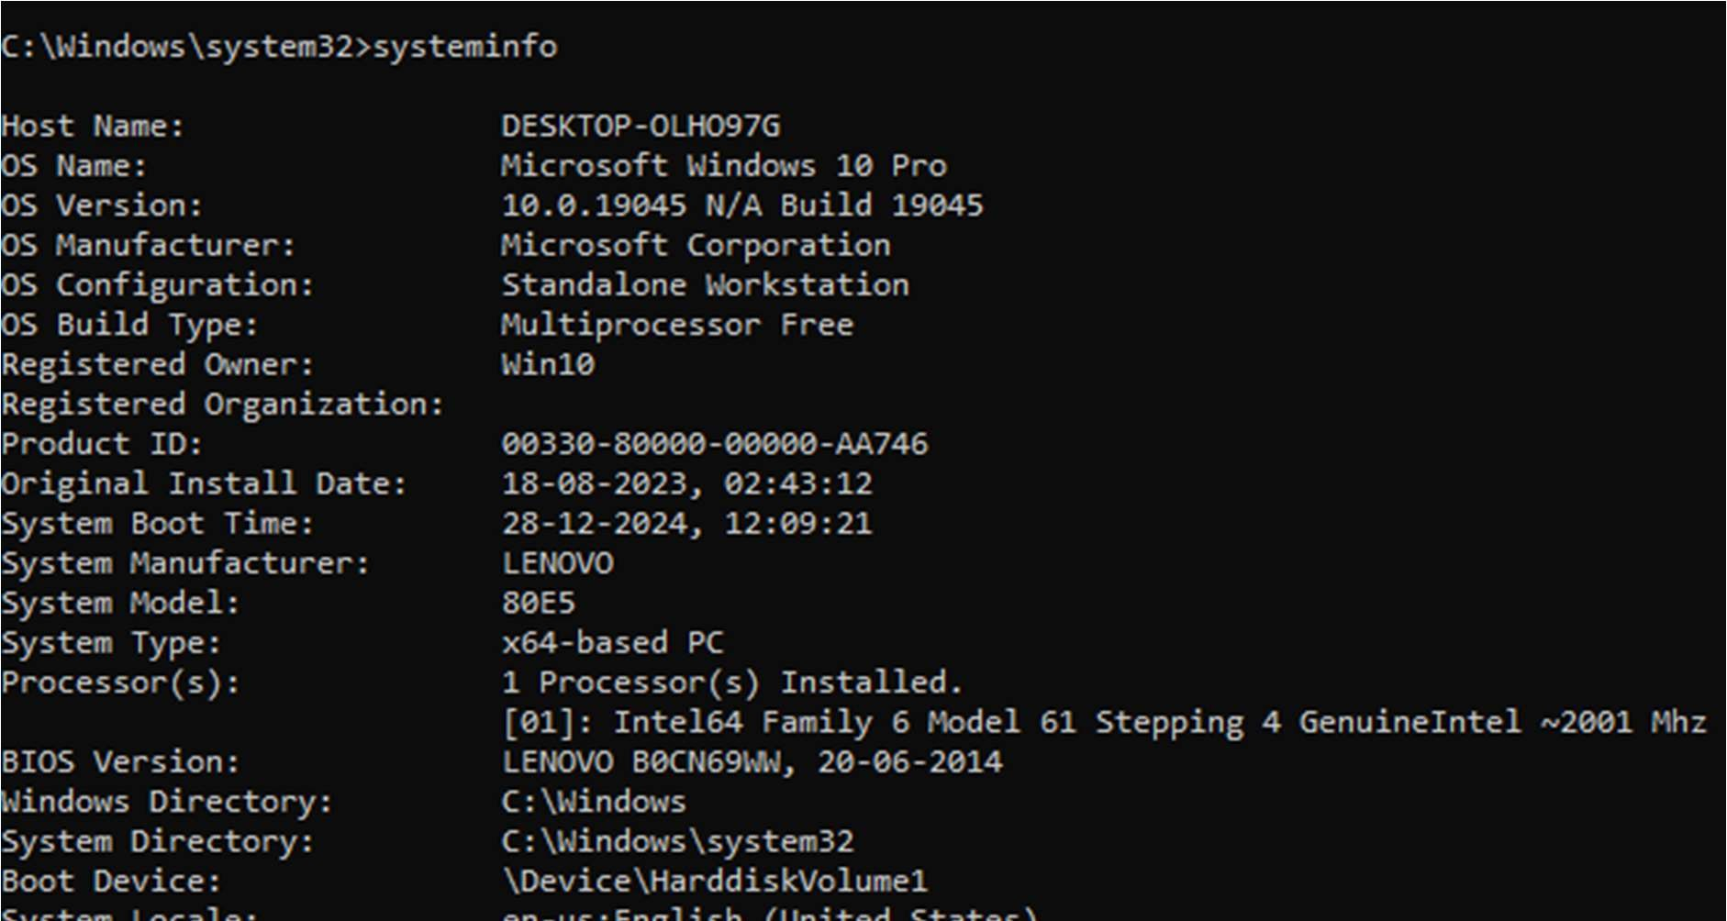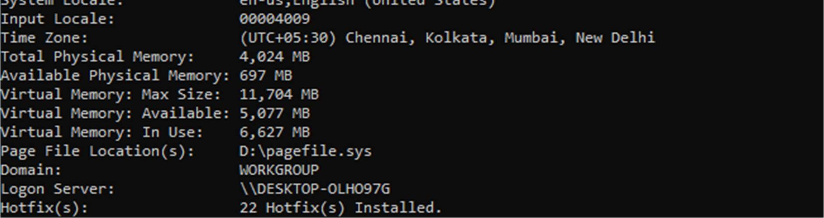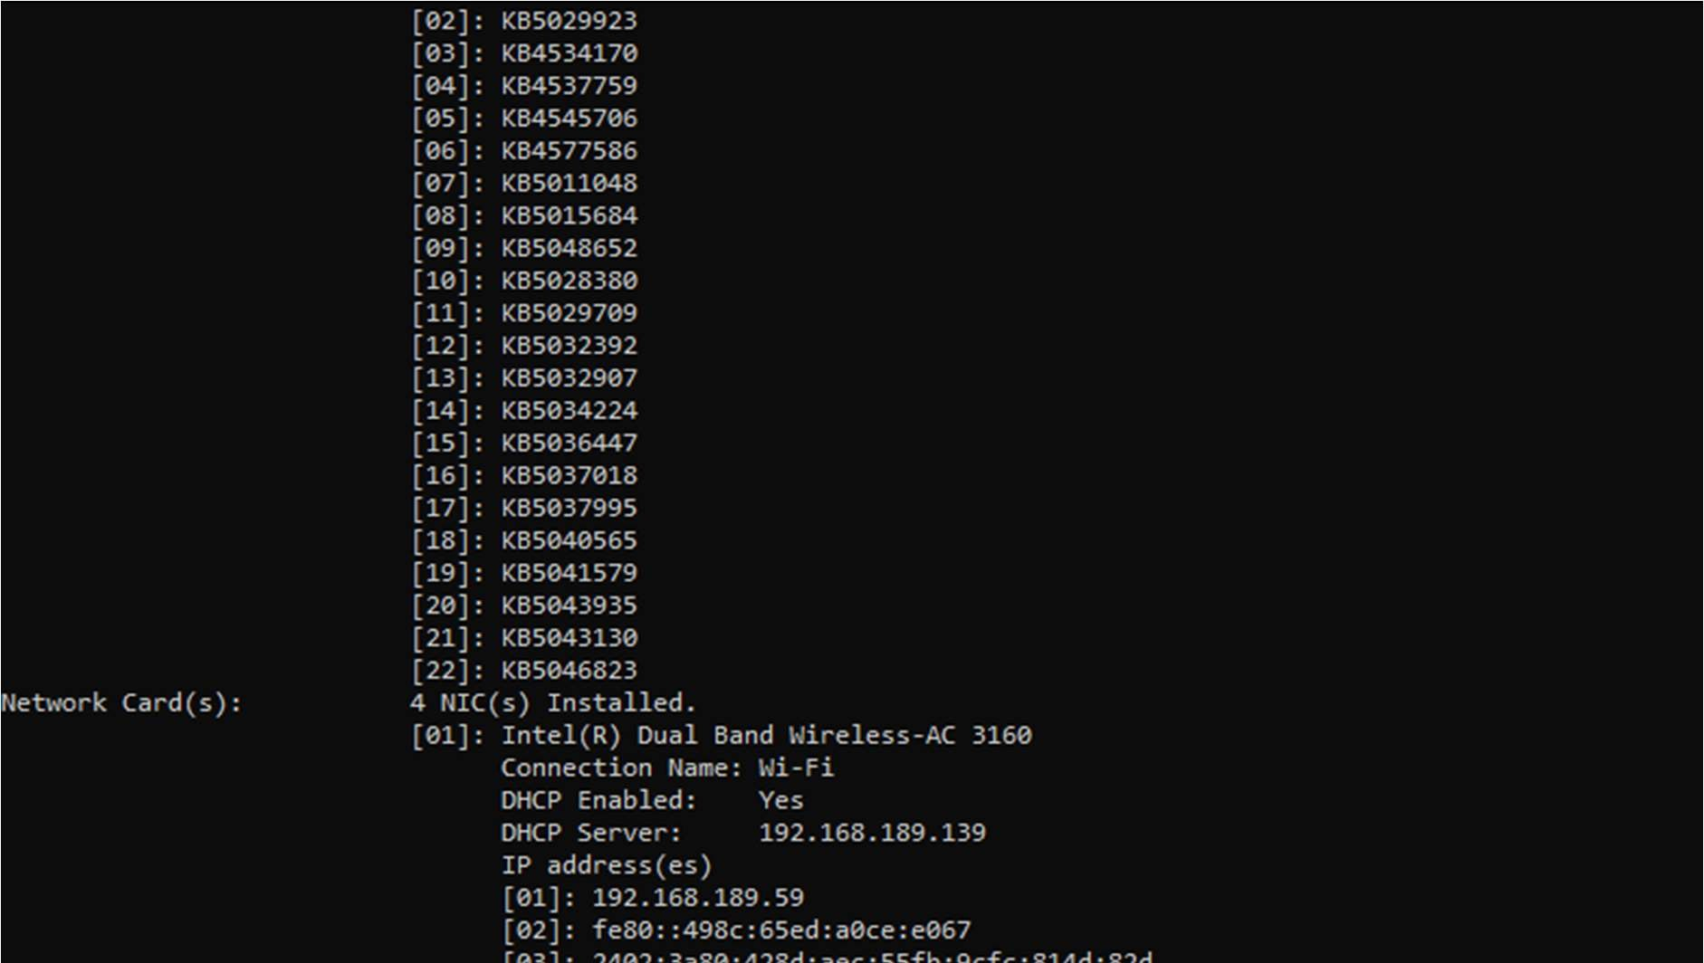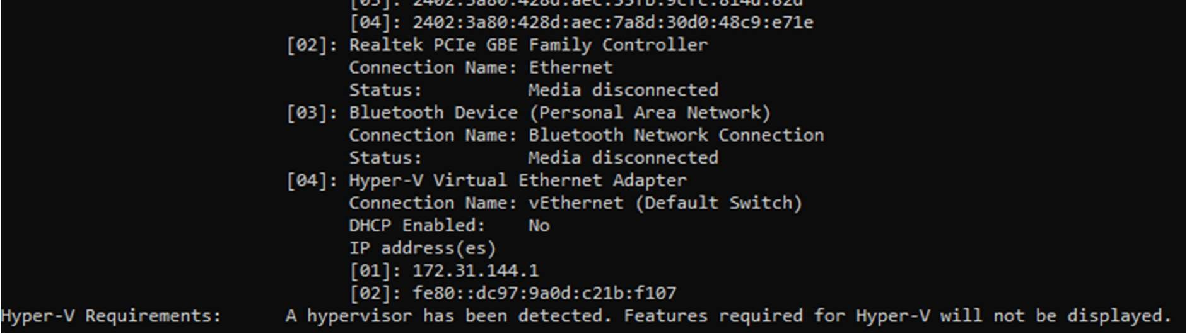

8.Arp

Displays and modifies the ARP table.

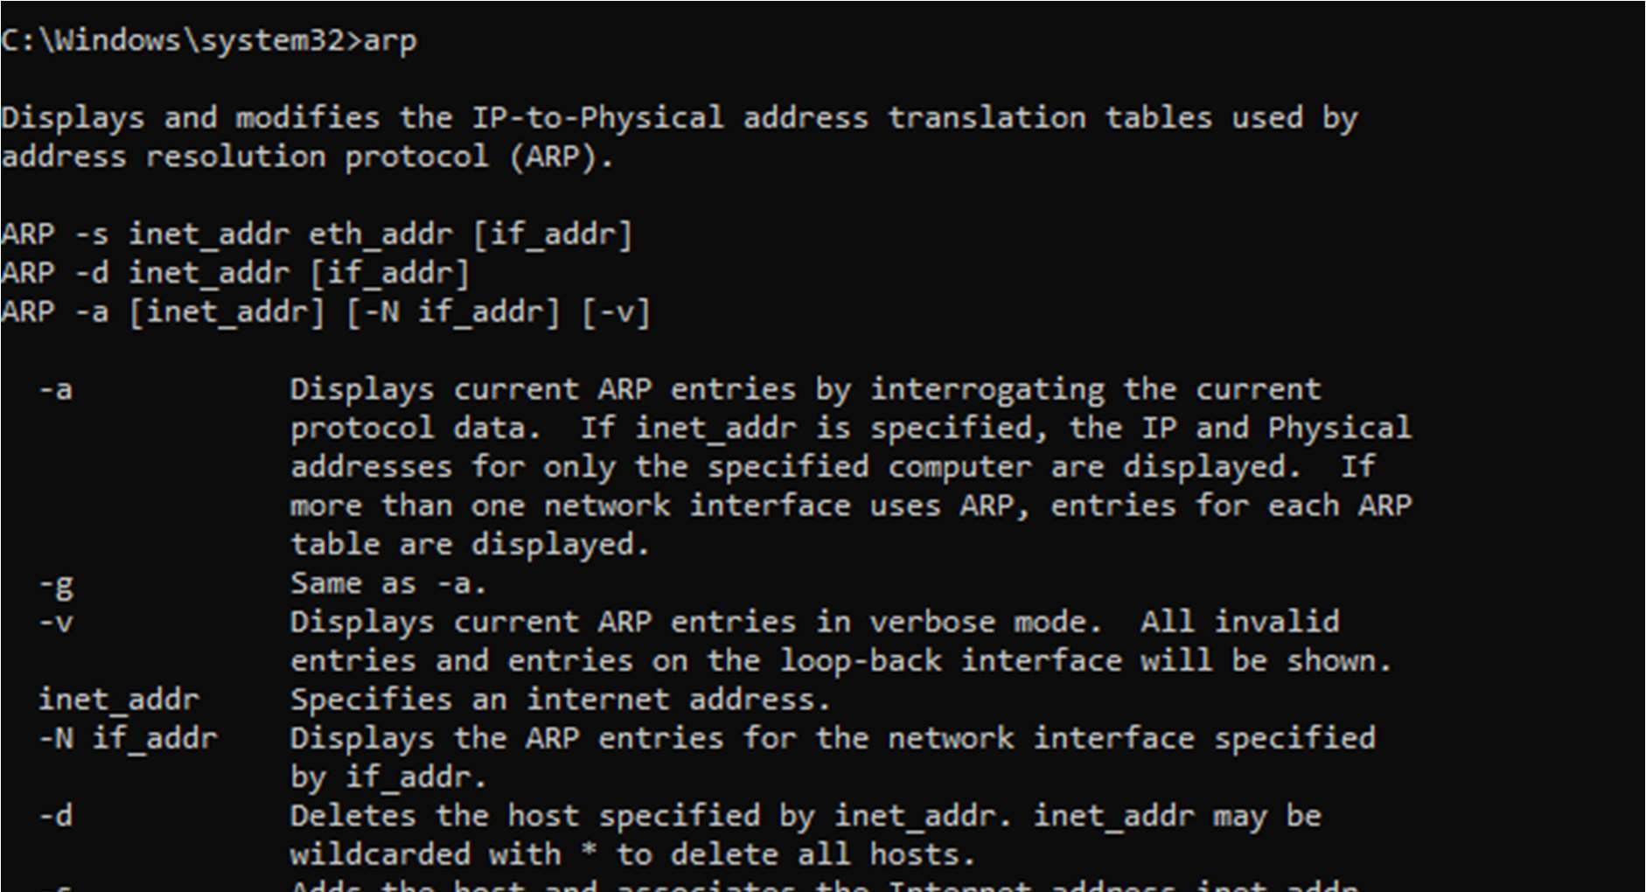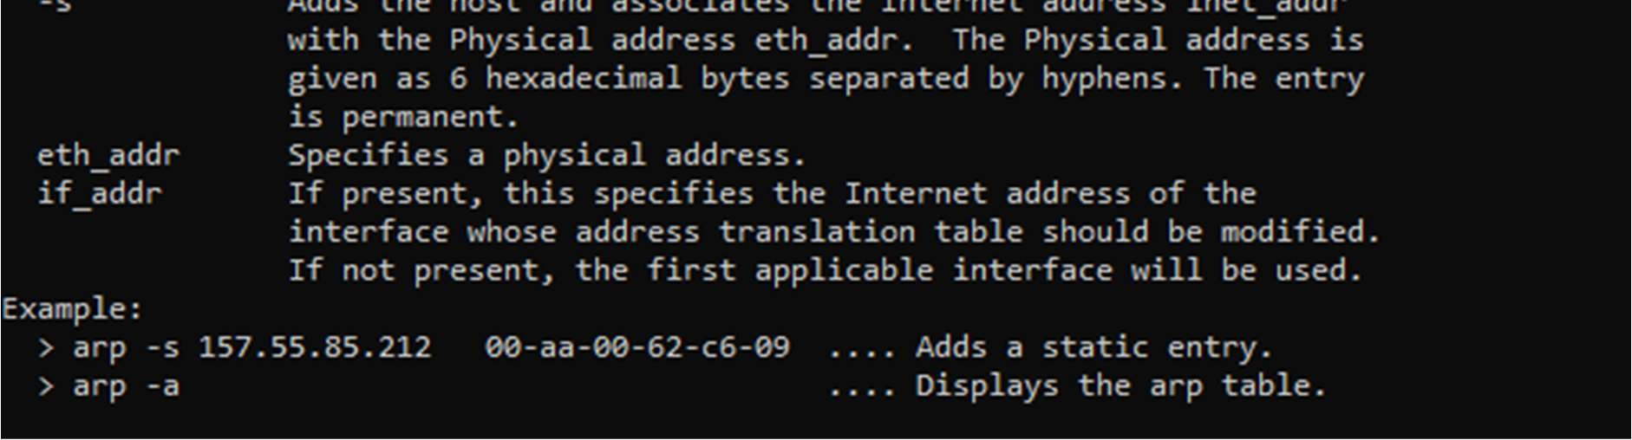

9.Getmac

Displays MAC addresses of network interfaces.

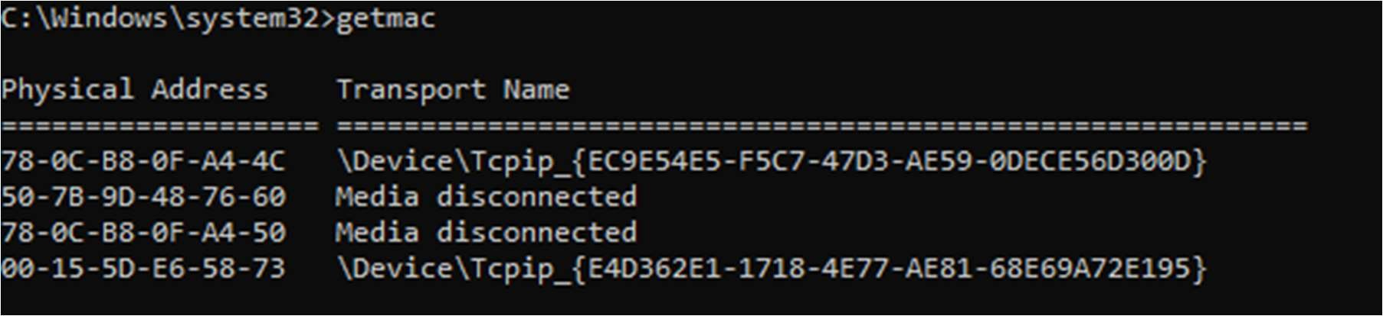

10.Ipconfig/release

Releases the current IP address.

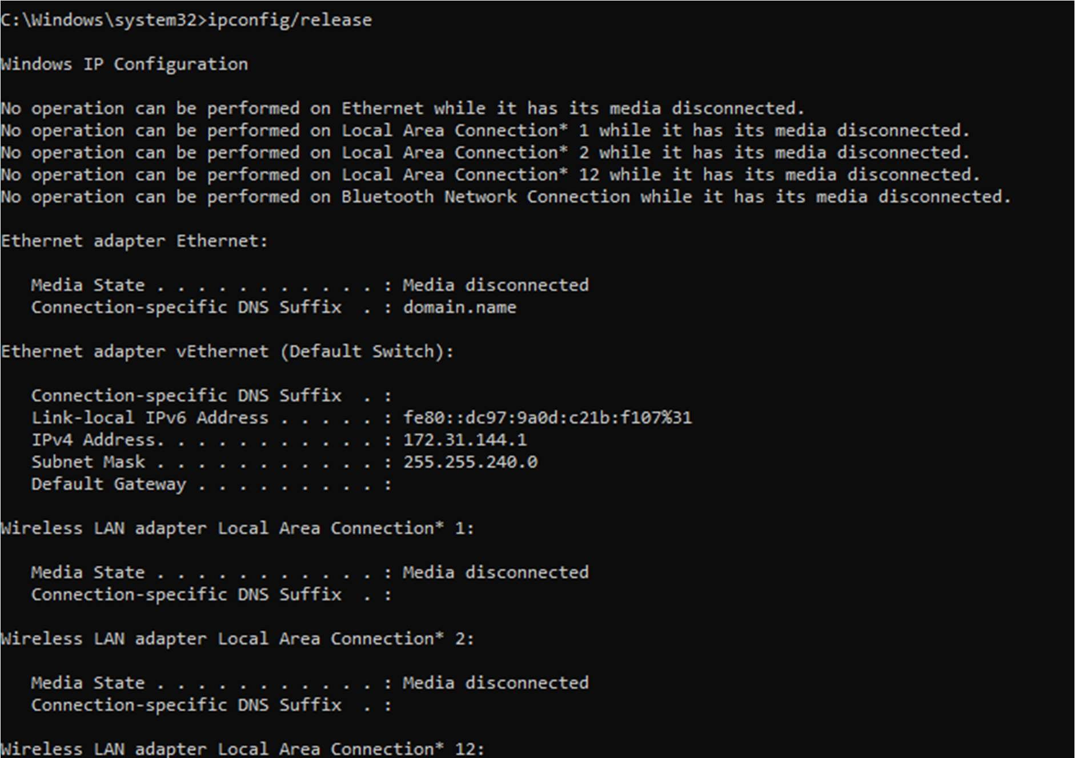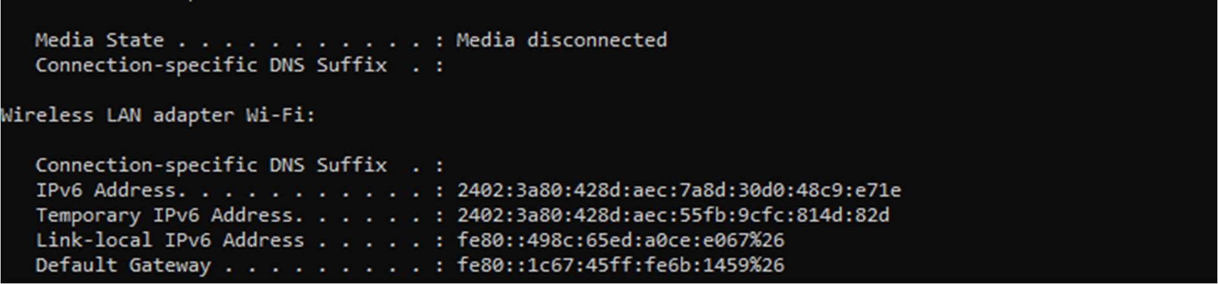

11.Tracert

Traces the path packets take to a des na on.

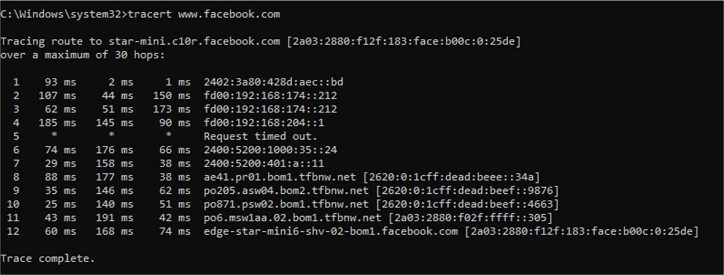

12.netsh wlan show profiles

Display a list of all Wi-Fi profiles stored on a Windows computer.

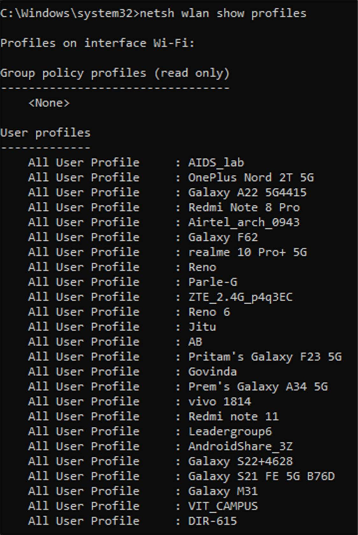

12. curl

Retrieves content from URLs (installed in newer versions of Windows by default).

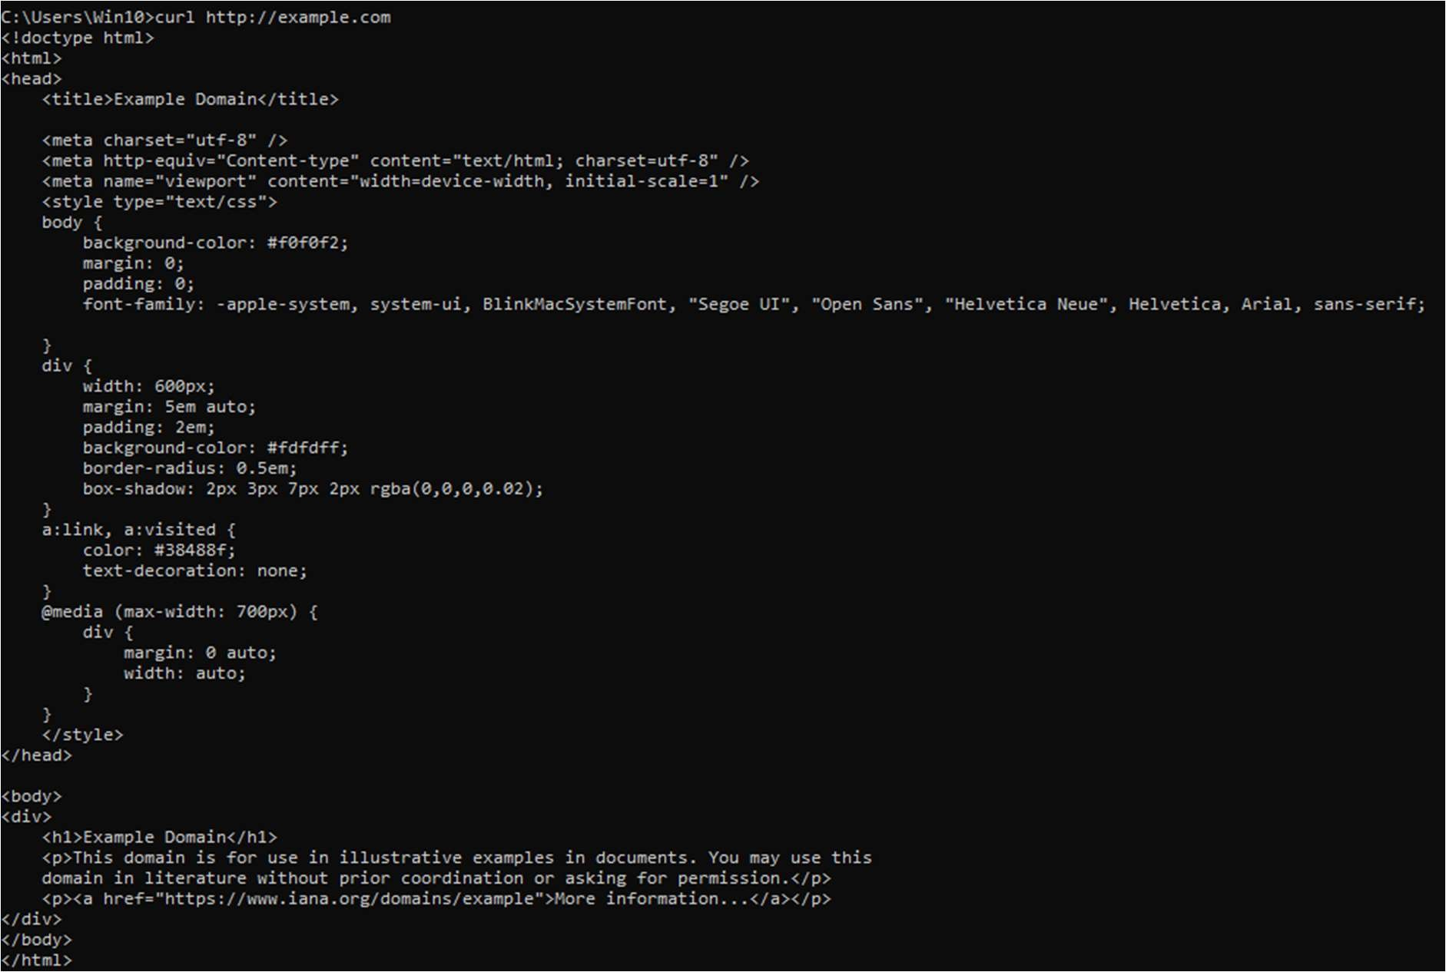

13.ssh

Securely opera ng network services over an unsecured network.

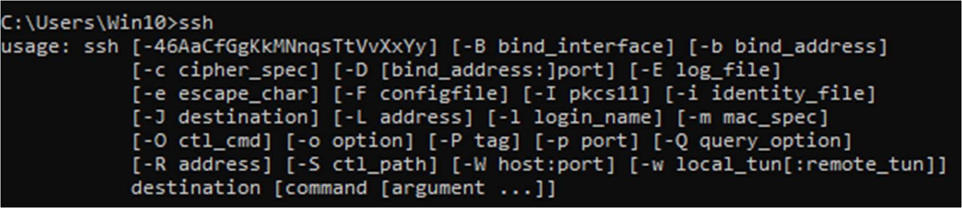

14.pathping google.com

This is combina on of ping and tracert.

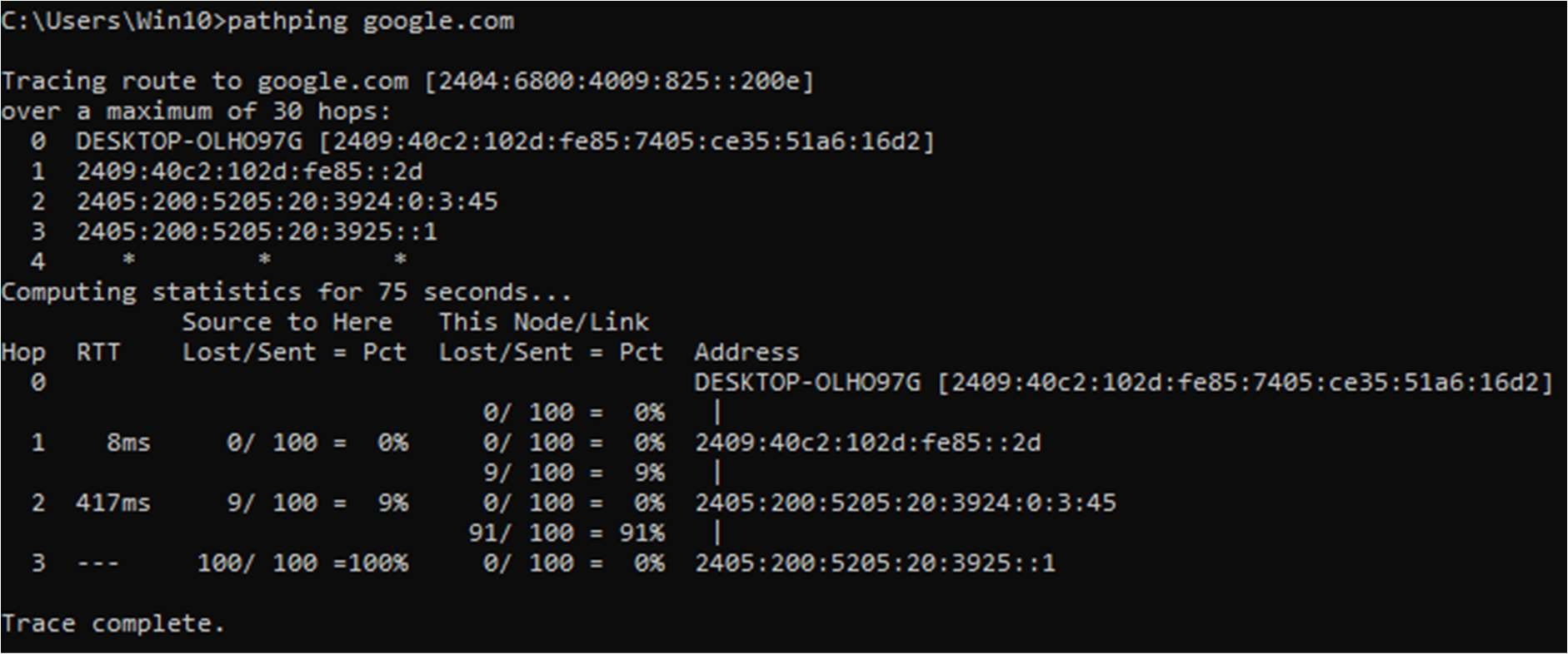

15.Whoami

Shows who is using PC.

